BRAIN/MIND LEARNING PRNCIPLES

Regina Rei Lamourelle, Ed.D.(2022)

1. Learner’s brains are unique!​
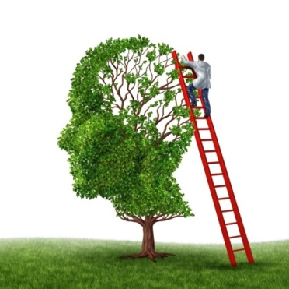
2. Learner’s brains are meaning driven.​
3. Emotions are critical to learning. Stress, threats,
and trauma alter brain functions and responses.​​
4. Learners are born to be a part of a social group.
Group work is brain appropriate. Supportive
relationships matter to reduce the effect of trauma.​
5. All learning is mind/body​
6. Cycles and rhythms affect all aspects of a learner’s interactions with educators​ (The brain has 90 minute on/off cycles 24 hrs./day.)
7. There are at least two memory systems involved in learning​. The implicit system with unlimited storage and easier recall and the explicit system with limited storage and requires more effort for recall.
8. Brains need food, water, and sleep to thrive (and to think, plan, learn and behave)!​
9. The brain is a multi-pathway processor that can process parts and whole information simultaneously in different modalities and is rarely over-stimulated​.
10. All learning is mind/body.​
11. Memory is dynamic and is created each time we recall an event. Apparently, we store memory in many body cells.​
12. The brain is highly adaptive and thrives on healthy, novel problem- solving opportunities.

( Adapted from Caine and Caine, 1991)​

